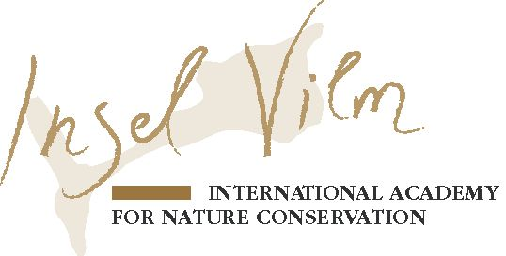
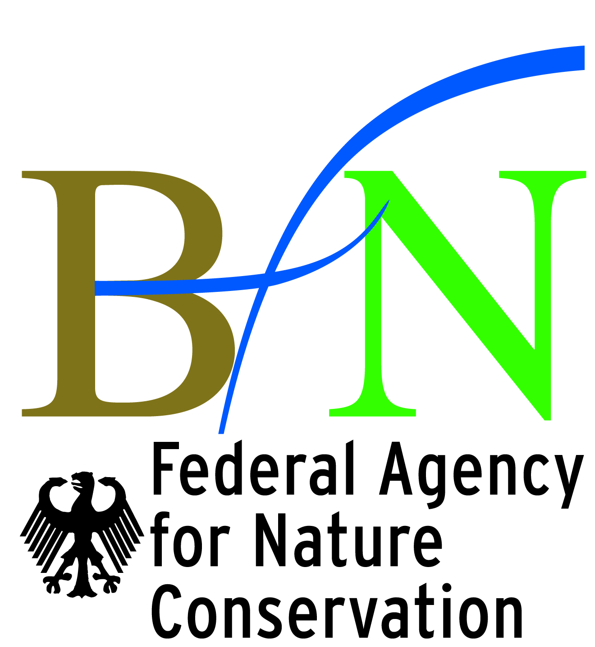
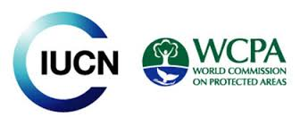

IUCN-WCPA Best Practice Guidelines Series:
Cultural and spiritual significance of nature in management and governance of protected and conserved areas

What are the three key criteria for case studies, experience stories and guideline examples?
We are looking for case studies, experience stories and guideline examples where the values and significance of nature:
- Are explicitly acknowledged and described,
- Play(ed) a significant role in management and/or governance of protected and conserved areas and,
- Provide valuable lessons that may have regional or global significance.

What is the difference between a case study, an experience story and a guideline example?
- Case studies are globally or regionally representative experiences, that generally need around one thousand words following the template below to describe the situation, values and lessons learned that may be relevant to others interested in learning to integrate and promote the cultural and spiritual significance of nature in the management and/or governance of protected and conserved areas.
Examples of case studies and how they can be used can be found in the IUCN UNESCO Best Practice Guidelines on Sacred Natural Sites: https://cmsdata.iucn.org/downloads/pa_guidelines_016_sacred_natural_sites.pdf
More elaborate case studies in printed form can be found with the Delos Initiative: http://www.med-ina.org/delos/index.htm (download proceedings from the Montserrat, Ouranoupolis, and Inari workshops) and examples of online case studies with the Sacred Natural Sites Initiative: http://sacrednaturalsites.org/sites/
- Experience stories are accounts, narratives and/or stories told by people involved in a specific situation related to key lessons learned on integrating and promoting the cultural and spiritual significance of nature in the management and/or governance of either individual protected and conserved areas or systems and networks of them. These can be told in words - perhaps illustrated with a photo of the person relaying the experience - and included in the printed Best Practice Guidelines and learning materials but also in video to be included in online materials.
Short video clips could look something like this: http://sacrednaturalsites.org/projects/in-perspective/
- Guideline examples correspond directly to guidance. There has been a practical situation in management or governance in which something was learned that directly translated into a guideline. These can be one or two paragraph descriptions of a management or policy issue in a protected or conserved area that has led to the development of a clear and specific guideline that may have regional or international importance.

What makes a good case study?
- Meets the three key criteria
- Demonstrates the living role of the cultural and spiritual significance of nature in management and governance of either a particular protected and conserved area, or a specific group of them, e.g. through the development of locally or regionally relevant customs or rules related to the use of natural resources or natural areas, or other cultural /spiritual practices related to nature.
- Has clear positive implications for nature conservation
- Follows a logical way of explaining the situation, a template is provided that can be modified,
- Uses clear and understandable language, including photographs, videos and lists additional resources such as websites, books and reports,
- Draws significant lessons learned from the case study or experience-story described,
- Where possible shows how guidance can be derived from the lessons learned and makes direct mention of implementation of guidance in management and governance.

What makes a good experience story?
- Meets the three key criteria
- Tells a personal experience of a person involved with the role of cultural and spiritual significance of nature in management and governance of protected and conserved areas,
- Tells the story from a personal experiential perspective, e.g. a manager, a local person or a decision maker and keeping them open to different interpretations,
- Demonstrate either key lessons learned, the need for guidance or the value of having appropriate guidance.

What makes a good guideline example?
- Meets the three key criteria
- Is very concise, e.g. a one or two paragraph description
- Contains a clear guideline which can also be relevant to other protected and conserved areas
- Briefly describes a practical and concrete situation in management or governance that led to the development of the guideline

What are the case studies, experience stories and guideline examples used for?
- Case studies, experience stories and guideline examples will be used to illustrate IUCN Best Practice Guidelines and training modules,
- They will be used as a teaching tool and learning reference in international workshops and as part of the curriculum of training modules,
- They will be displayed online and integrated into the above mentioned guidance and training materials and approaches,
- Should you have more to tell about your case study or experience then please consider and discuss the opportunity to contribute a 6000 Word chapter to a forthcoming book on the subject that will be published with Routledge,
- With your permission case studies can be proposed for inclusion in “Panorama” which is IUCN’s initiative to promote case studies that showcase how protected areas provide solutions to some of the world’s challenges, including through a web platform, workshops and communication products.

Who is the audience?
- You are writing for an international audience coming from very different geographical, professional, ethnic and religious backgrounds,
- They are all involved with the management and/or governance of protected and conserved areas,
- They can be protected area managers, field practitioners, conservation professionals, decision-makers rangers, etc. They may belong to or represent indigenous peoples, NGOs, different religious or spiritual organizations, looking after the protected or conserved area,
- English may not be their primary or even secondary language.

When do we need them?
- We will accept case studies and experience stories any time.
- From July 2016 onward we can help you improve them.
- To include the case study in the printed version of the BPG, we would ultimately need them before July 2017. After this we can only display them online.

Let us know if you:
- Need any help or in case you have any questions and we’d be happy to help you,
- Have suggestions to improve or share your successes and learning experience with your colleagues.

Contact information:
Bas Verschuuren (CSVPA Co-Chair) basverschuuren@gmail.com
Edwin Bernbaum (CSVPA Co-Chair) ebernbaum@mountain.org
Josep-Maria Mallarach (CSVPA Steering Committee member) mallarach@silene.es

More information:
www.csvpa.org

The Case Study Template:

Title (20 words)
- Describes the nature of the case study or the key actors
- Mentions the name of the location (country at the minimum) and the name of the of protected or conserved area, site, territory

Summary (180)
- Short summary of the key aspects and lessons learned

Cultural and spiritual significance of nature (200)
- Main cultural and spiritual significance attributed to nature in general and natural features in particular
- An explanation of the worldviews, religions or spiritual importance at the basis of the significance
- Description or typology of the key values and significance at play in the conservation of the protected or conserved area

Ecology and biodiversity (100)
- Description of the specific biodiversity, ecology or landscape that is at the basis of, or influenced by the cultural and spiritual significance of nature
- The geographical and ecological configuration of the broader land and seascape (or region) were relevant
- Main strengths, weaknesses, opportunities and threats (SWOT)

Governance (100)
If your case study deals only with management, please go to the next section. Governance is about who decides about what is to be done, and how those decisions are taken. It is about who holds power, authority and responsibility and who is, or should be, held accountable:
- Type of governance IUCN PA Matrix (see Annex 1)
- Introduce the governance actors/stakeholders and their roles and points of view,
- What are the main competing or synergizing values and perspectives of the key stakeholders involved (without repeating the management issues)
- Key governance arrangements and agreements between stakeholders
- Principles established for governance (transparent, inclusive, etc.)
- Legal arrangements required (national law, traditional law, earth jurisprudence)
- What are the key issues that require solutions in terms of integrating cultural and spiritual significance of nature in governance and management of protected and conserved areas?
- Implications for management (bridge to the next section)

Management (100)
If your case study deals only with governance, please go to the previous section. Management is about what is done in pursuit of given objectives (be aware that in this context ‘management’ includes planning and evaluation):
- Who are the protected or conserved area’s managers (Government, private indigenous, religious or members of the local public, co-management,…)?
- Who are the key stakeholders and stakeholder groups both local and distant (mainstream religions, indigenous and local, members or representatives of certain social sectors, such as tourism, or the general public)
- What are the main competing or synergizing values and perspectives of the key stakeholders involved (without repeating the governance issues)
- What are the roles of the protected and conserved area managers in relation to the cultural and spiritual significance of nature?
- What are the main issues (obstacles, problems or needs for synergies) that require you to find ways of integrating the cultural and spiritual significance of nature in the governance and management of protected and conserved areas?

Lessons learned/best practices (300)
- Describe the area in which the main lessons have been learned such as: management, policy, (self) governance, visitor interpretation, environmental education, management effectiveness, financing, sacred natural sites, recreation, meditation, religious services, cultural sustenance, capacity building, advocacy, etc.
- What were the actions implemented to take the cultural and spiritual significance of nature into account in management or governance?
- Can you distill any clear advice or guidance from your experience?
- What conservation or other tools or processes have you deployed to achieve this?
- How did these ideas and actions become translated to management, governance or policy or guidelines?
- Other ideas or suggestions that convey your story?

Resources/References (unlimited)
- This section includes bibliographic references to scientific, grey and other literature along with any links to important websites of organizations, projects and videos

Contact information
- Your contact information

Photos
- Please provide 3 to 8 high-resolution photos for use in the online case study presentation and possibly in the printed volume of the best practice guidelines. Should you have more photos available then please let us know, we can use these to make the online presentation more attractive

Quotes
Inspiring quotes of people working in the importance of cultural and spiritual significance of nature in governance and management of protected and conserved areas

Annex 1. IUCN Matrix on Protected Area categories and Governance Types.

Governance type | Category (management objective)  Governance sub-type | I | II | III | IV | V | VI
 |  | Strict Nature Reserve, Wilderness Area | National Park (ecosystem protection; protection of cultural values) | Natural Monument | Habitat/ Species Management | Protected Landscape/ Seascape | Managed Resource
A.  Governance by Government | Federal or national ministry or agency
 | Local/ municipal ministry or agency in change
 | Government-delegated management (e.g. to an NGO)
B.  Shared Governance | Trans-boundary management
 | Collaborative management (various forms of pluralist influence)
 | Joint management (pluralist management board)
C.  Private Governance | Declared and run by individual land-owner
 | by non-profit organisations (e.g. NGOs, univ. etc.)
 | …by for profit organisations (e.g. corporate land-owners )
D.  Indigenous Peoples & Community Governance | Indigenous Territories- declared and run by Indigenous Peoples
 | Community Conserved Areas - declared and run by local communities

